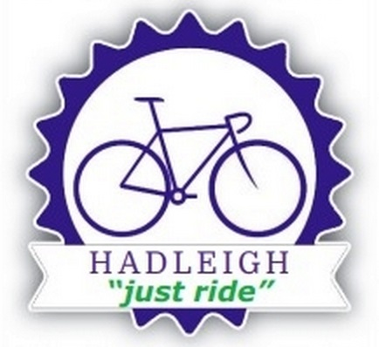
Hadleigh Cycling Club

Safeguarding – A Short Guide for Club Members
Hadleigh Cycling Club is committed to ensure that children and young people involved in our activities can thrive and flourish in a safe environment and that all children, young people and adults at risk have a fun, safe and positive experience.

Hadleigh Cycling Club is an affiliated member of British Cycling and follows the British Cycling Safeguarding Policy and procedures.

You may be wondering “What does safeguarding actually mean?”
Safeguarding is a term used to describe measures that are in place to protect the health and wellbeing of individuals, especially children and other vulnerable groups, to live free from abuse, harm and neglect.
Your next question might be “What has safeguarding got to do with me?”
Government guidance makes it clear that ‘Safeguarding is everyone’s responsibility’.
Anyone who has a negative experience of sport at a young age is less likely to become a regular long-term participant. It’s important for the future of your club and the sport as a whole that children and young people have an enjoyable experience.
By getting safeguarding right for both adults and children, we will ensure safe access to participation in sport and physical activity for everyone.
All club members have a part to play in making that happen.
All our members should contribute to the club meeting its overall duty of care, be aware of our club’s safeguarding procedures, and know what to do if they have any concerns.

Hadleigh Cycling Club asks our members to:
Familiarise yourself with the Hadleigh Cycling Club policies on:
- Safeguarding
- Hadleigh Cycling Club Codes of Conduct
- Anti-Bullying policy
- Transport policy
- Social Media policy

All the above and full copies of the Hadleigh Cycling Club Safeguarding Policies are available on our website Welcome | Hadleigh Cycling Club | Hadleigh

What should I do if I have a concern?
A concern may involve the behaviour of an individual towards a child or adult whilst at the club.

A concern may relate to poor practice or something more serious.

You may be worried that something has happened to a child or adult outside the club, at their home or any other social setting.

Children, young people and adults at risk may confide in adults they trust, in a place where they feel comfortable.

An allegation may range from verbal bullying, to inappropriate contact online, neglect or emotional abuse, to physical or sexual abuse.

If you have a concern, it is not your responsibility to investigate further, but it is your responsibility to act on your concerns and share them.

Pass the information to Hadleigh Cycling Club Welfare Officer who will follow the club’s Safeguarding procedures.

Name: Kate Billingham
Email Address: kate@katebillingham.org.uk
Telephone Number: 07710757470
If you believe someone may be at immediate risk of harm, call the Police or you local Social Care Department.

Other useful contacts:
NSPCC 24-hour helpline Tel: 0808 800 5000
Ann Craft Trust – Safeguarding Adults in Sport and Activity Tel: 0115 951 5400
British Cycling Lead Safeguarding Officer 0161 2742000

